**NAME: MARIA HAROON**

**ROLL NO. 20011598-058**

**SECTION: 6-B**

**MICROSERVICE IN PYTHON**

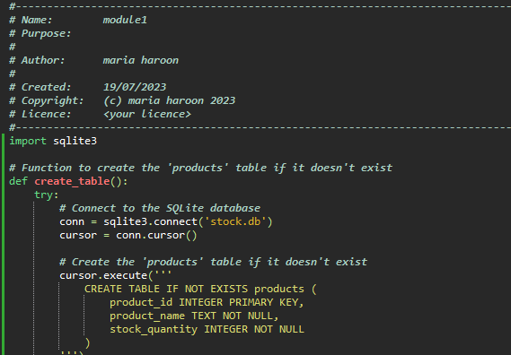

**OUTPUT**

